Daily Derivatives & Market Report

|  |
| --- |
| **CONTENTS** |
| |  |  | | --- | --- | | **Page No.** | **Particulars** | | 2 | Market Summary | | 3 | Nifty Futures – Derivatives Snap | | 4 | Bank Nifty Futures – Derivatives Snap | | 5 | Activity in Nifty Options | | 6 | What do Nifty Technical suggest | | 7 | Disclaimer | |  |  |   Index Trend Analysis   |  |  |  |  |  |  |  |  |  |  | | --- | --- | --- | --- | --- | --- | --- | --- | --- | --- | | **Pivot(Daily)** | **Close** | **S2** | **S1** | **Pivot** | **R1** | **R2** | **Daily** | **Weekly** | **Monthly** | | **Nifty** | **11662** | **11520** | **11591** | **11636** | **11707** | **11752** | **Buy** | **Buy** | **Buy** | | **Sensex** | **39575** | **39030** | **39303** | **39463** | **39735** | **39896** | **Buy** | **Buy** | **Buy** | | **Nifty Futures** | **11672** | **11523** | **11598** | **11641** | **11715** | **11758** | **Buy** | **Buy** | **Buy** | | **Bank Nifty** | **22854** | **22384** | **22619** | **22756** | **22991** | **23129** | **Neutral** | **Neutral** | **Sell** | | **CNX IT** | **20897** | **20401** | **20649** | **20822** | **21070** | **21243** | **Buy** | **Buy** | **Buy** | | **CNX Midcap** | **17216** | **17097** | **17157** | **17211** | **17271** | **17326** | **Buy** | **Buy** | **Neutral** | | **CNX Small Cap** | **5924** | **5884** | **5904** | **5928** | **5948** | **5971** | **Buy** | **Buy** | **Neutral** | |

Market Summary

|  |  |  |  |  |
| --- | --- | --- | --- | --- |
| Domestic Indices | Close | | Points | % Chg |
| SENSEX | | 39574.57 | 600.87 | 1.54 |
| NIFTY | | 11662.40 | 159.05 | 1.38 |
| MIDCAP | | 14873.87 | 87.29 | 0.59 |
| SMLCAP | | 15110.39 | 82.41 | 0.55 |
| BSEFMC | | 11135.79 | -11.71 | -0.11 |
| AUTO | | 18204.22 | 225.41 | 1.25 |
| POWER | | 1657.44 | -3.23 | -0.19 |
| REALTY | | 1749.03 | 41.16 | 2.41 |
| BSE IT | | 21094.92 | 116.67 | 0.56 |
| BANKEX | | 25951.60 | 523.84 | 2.06 |
| OILGAS | | 12223.51 | -27.54 | -0.22 |
| METAL | | 8509.63 | -49.53 | -0.58 |

|  |  |  |  |
| --- | --- | --- | --- |
| Currency Futures | Close | Pre. Pts | % Chg |
| 27-Oct-20 USD-INR | 73.58 | 0.17 | 0.23 |
| 27-Oct-20 EUR-INR | 86.72 | 0.43 | 0.50 |
| 27-Oct-20 GBP-INR | 95.21 | 0.20 | 0.21 |
| 27-Oct-20 JPY- INR | 69.69 | 0.18 | 0.26 |

|  |  |  |  |
| --- | --- | --- | --- |
| Advance/ Decline | Adv | Dec | Un Ch. |
| NSE | 1107 | 785 | 117 |
| BSE | 1512 | 1196 | 154 |

|  |  |  |  |
| --- | --- | --- | --- |
| FII/DII Capital Mkt* | Buy | Sell | Net |
| **DII** | 3077 | 4012 | (935) |
| **FII** | 6073 | 4971 | 1102 |

*\*NOTE: - FII AND DII data figure is provisional*

Market Commentary

***Indian equity benchmarks ended near day’s high points on Tuesday. After a positive start of the day, key indices remained higher for the whole day, taking support with Commerce Minister Piyush Goyal’s statement Indian exports will automatically increase if the products are good and competitively priced and that products are entrepreneurs should not think that subsidies are the only solution. Traders took support with IT Minister Ravi Shankar Prasad’s statement that artificial intelligence (AI) has massive potential to generate development and India is well-poised to tap into the opportunity with its large pool of skilled professionals.***

***Markets extended their gains in the last hour of the trade, as India’s service sector activity stabilised in the month of September, with the relaxation of coronavirus pandemic 2019 (COVID-19) restrictions. As per the survey report, the seasonally adjusted Nikkei Services Business Activity Index rose to 49.8 in September from 41.8 in August. Further, the Nikkei India Composite PMI Output Index -- which measures both manufacturing and services - surged to 54.6 in September from 46.0 in August. The Street took note of report that the government appointed Ashima Goyal, Jayanth R Varma and Shashanka Bhide as members of the rate-setting Monetary Policy Committee (MPC) of the RBI.***

***On the global front, European markets were trading lower. Asian markets ended mostly higher on Tuesday, even after consumer prices in South Korea were up 1.0 percent on year in September, Statistics Korea said on Tuesday - exceeding expectations for a gain of 0.7 percent, which would have been unchanged from August. On a monthly basis, inflation rose 0.7 percent - again beating forecasts for 0.4 percent and up from 0.6 percent in the previous month. Core CPI, which excludes volatile food prices, rose 0.1 percent on month and 0.6 percent on year after rising 0.2 percent on month and 0.4 percent on year in August.***

Market Turnover & FII Derivative Data

|  |  |  |  |
| --- | --- | --- | --- |
| Market TO | Current | Previous | Net% |
| BSE CASH | 2807 | 2767 | 1 |
| NSE CASH | 49804 | 51739 | (4) |
| NSE FO | 1655525 | 1562325 | 6 |

|  |  |  |  |
| --- | --- | --- | --- |
| FII Derivatives | Buy | Sell | Net |
| Ind. Futures | 2779.05 | 3293.00 | (514) |
| Ind. Options | 176210 | 174436 | 768 |
| Stk. Futures | 21653 | 21305 | (125) |
| Stk. Options | 4095.66 | 4150.27 | (55) |

Nifty Futures

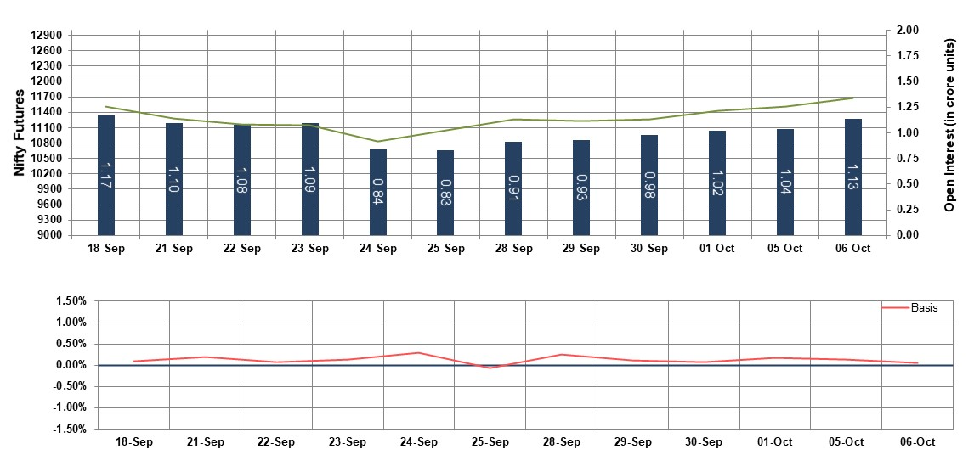

Bank Nifty Futures

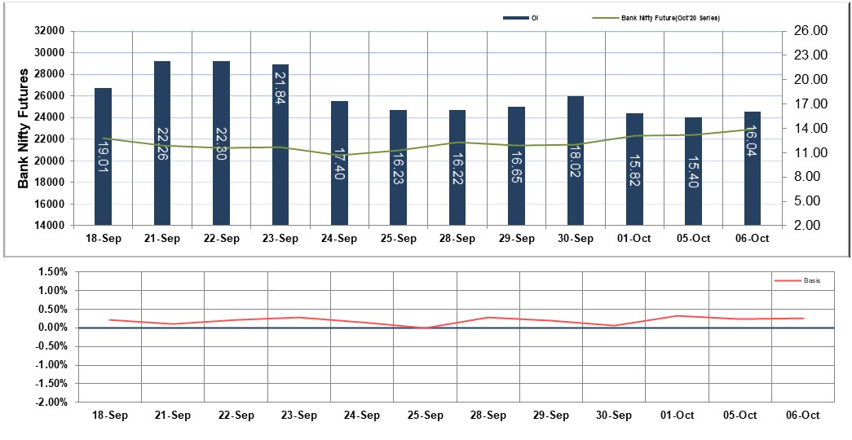

Nifty Options

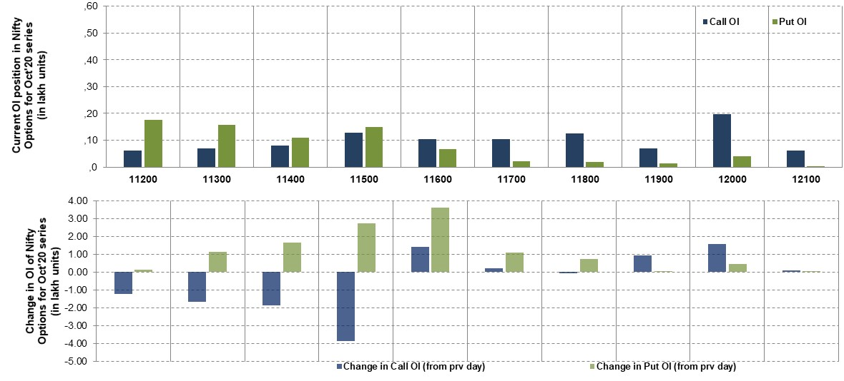

*Note – Change in OI of Nifty Options refers to change from previous trading day*

*Source-NSE, SIHL Derivatives Research (Institutional Equities)*

* Among Nifty calls 12,000 SP from the Oct month expiry was the most active call with an addition of 0.16 million in open interests.
* Among Nifty puts 11,200 SP from the Oct month expiry was the most active put with an addition of 0.01 million in open interests.
* The maximum OI outstanding for Calls was at 12,000 SP (1.97mn) and that for Puts was at 11,200 SP (1.77mn)

Nifty Technical & Indices Levels

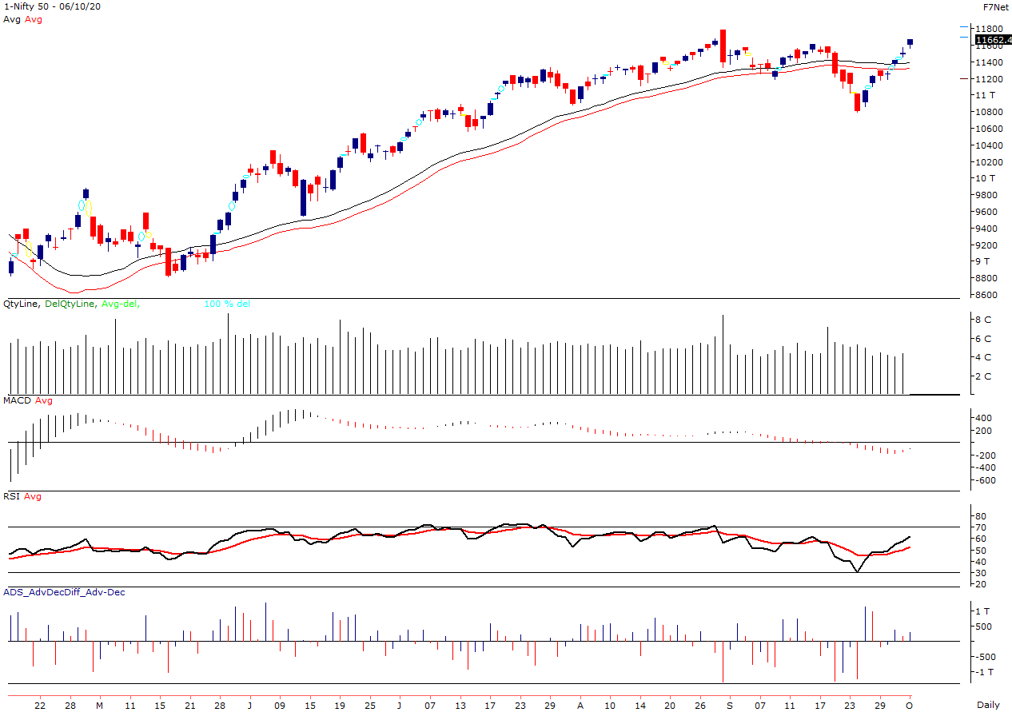

Nifty Cash prices have settled at 11662.40 up by 1.38 percent from the previous close. On the upper side it has resistance of 11780 and 11810 levels, while lower side it has support of 11550 and 11480 levels. Intraday traders should be cautious and take position accordingly.

|  |
| --- |
|  |
| Disclaimer:  The InformSation provided by SMS or in newsletter or in any document has been prepared by Shah Investor’s Home Ltd (SIHL). The Information provided by SMS or in newsletter does not constitute an offer or solicitation for the purchase or sale of any financial instrument or as an official confirmation of any transaction. The information contained herein is from publicly available data or other sources believed to be reliable, but we do not represent that it is accurate or complete and it should not be relied on as such. SIHL or any of its affiliates/ group companies shall not be in any way responsible for any loss or damage that may arise to any person from any inadvertent error in the information contained in this report or SMS. This Information provided by SMS, reports or in newsletter is provided for assistance only and is not intended to be and must not alone be taken as the basis for an investment decision. The user assumes the entire risk of any use made of this information. Each recipient of this Information provided by SMS, report or in newsletter should make such investigation as it deems necessary to arrive at an independent evaluation of an investment in the securities of companies referred to in this information provided by SMS, report or in newsletter (including the merits and risks involved), and should consult his own advisors to determine the merits and risks of such investment. The investment discussed or views expressed may not be suitable for all investors. This information is strictly confidential and is being furnished to you solely for your information.  The information should not be reproduced or redistributed or passed on directly or indirectly in any form to any other person or published, copied, in whole or in part, for any purpose. The information provided by report or SMS is not directed or intended for distribution to, or use by, any person or entity who is a citizen or resident of or located in any locality, state, country or other jurisdiction, where such distribution, publication, availability or use would be contrary to law, regulation or which would subject SIHL and affiliates/ group companies to any registration or licensing requirements within such jurisdiction. The distribution of this Information provided by SMS or in newsletter in certain jurisdictions may be restricted by law, and persons in whose possession this Information provided by SMS or in newsletter comes, should inform themselves about and observe, any such restrictions. The information given or Information provided by SMS, report or in newsletter is as of the date of the issue date of report or the date on which SMS provided and there can be no assurance that future results or events will be consistent with this information. This information is subject to change without any prior notice. SIHL reserves the right to make modifications and alterations to this statement as may be required from time to time. However, SIHL is under no obligation to update or keep the information current.  Nevertheless, SIHL is committed to providing independent and transparent recommendation to its client and would be happy to provide any information in response to specific client queries. Neither SIHL nor any of its affiliates, group companies, directors, employees, agents or representatives shall be liable for any damages whether direct, indirect, special or consequential including lost revenue or lost profits that may arise from or in connection with the use of the information. Past performance is not necessarily a guide to future performance. The disclosures of interest statements incorporated in the Information provided by SMS, report or in newsletter are provided solely to enhance the transparency and should not be treated as endorsement of the views expressed in the report. The analyst for this report certifies that all of the views expressed in this report accurately reflect his or her personal views about the subject company or companies and its or their securities, and no part of his or her compensation was, is or will be, directly or indirectly related to specific recommendations or views expressed in this report.  About Us:  Shah Investor’s Home Ltd (SIHL) is an ISO 9001:2008 Certified financial Services Company established in 1994 at Ahmadabad, Gujarat. Customer satisfaction is guaranteed through our diversified product portfolio, professional management and customer first attitude. SIHL was the first broking house in Gujarat with membership in National Securities Depository Ltd (NSDL) and was the first broking name providing services in NSE F&O in Ahmedabad. Today, SIHL ranks among the top most players in Gujarat in retail stock broking area with 45 branches, 350 franchisee across India and providing service to more than 1,25,000 clients. |